AMini Project Report

On

**ARINFOCRAFT**

*Submitted in partial fulfillment of the requirements for the award of the degree of*

**BACHELOR OF** **TECHNOLOGY**

IN

**COMPUTER SCIENCE AND ENGINEERING**

**BY**

**Ms.RASGANA (14N81A0566)**

**Ms. C. PRAVALIKA (14N81A0589)**

**Mr. M. ABHISHEK(14N81A0591)**

Under the guidance of

**Mr. K. PAVAN KUMAR**

**ASSISTANT PROFESSOR**

DEPARTMENT OF COMPUTER SCIENCE AND ENGINEERING



**Department of Computer Science and Engineering**

**Sphoorthy Engineering College**

**Naderagul (Vill.), Sagar Road, Near Vanasthalipuram, Saroornagar (Mdl.), R. R. Dist., Telangana. – 501510**

**2012-2016**

PAGE:1

**DECLARATION**

We, the undersigned, declare that the project title “**ARINFOCRAFT**” carried out at “SPHOORTHY ENGINEERING COLLEGE” is original and is being submitted to the Department of COMPUTER SCIENCE AND ENGINEERING, Sphoorthy Engineering College, Hyderabad towards partial fulfillment for the award of Bachelor of Technology.

We, declare that, the result embodied in the Project work has not been submitted to any other University or Institute for the award of any Degree or Diploma.

**Date: RASAGNA**

**Place: Hyderabad 14N81A0566**

**PRAVALIKA**

**14N81A0589**

**ABHISHEK MURUMKAR**

**14N81A0591**

PAGE:2



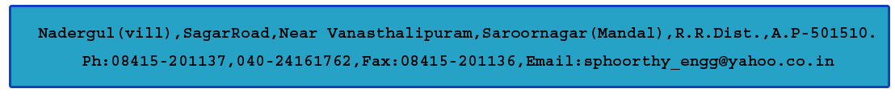

**DEPARTMENT OF COMPUTER SCIENCE AND ENGINEERING**

**CERTIFICATE**

This is to certify that project entitled “**ARINFOCRAFT”** is a bonafide work carried out by Ms. RASAGNA (14N81A0566), Ms. C. PRAVALIKA (14N81A0589), Mr. M. ABHISHEK (14N81A0591), in partial fulfillment for the award of Bachelor of Technology in Computer Science and Engineering, Sphoorthy Engineering College, Hyderabad during the year 2015-2016 under my supervision and guidance. The result embodied in the Project Work has not been submitted to any other University or Institute for the award of any Degree or Diploma.

**INTERNAL GUIDE HEAD OF DEPARTMENT**

**Mr. K. PAVAN KUMAR** **Mrs. J. DEEPTHI**

Assistant Professor Assistant Professor

**EXTERNAL EXAMINER**  **PRINCIPAL**

**DR. K.S. SHAJI**

**ACKNOWLEDGEMENT**

The completion of this project work gives us an opportunity to convey our gratitude to all those who have helped us to reach a stage where we have the confidence to launch our career in the competitive world in the field of Computer Science.

We would like to express our heartfelt thanks to **External Guide** forpermitting us to do a project work in their esteemed organization.

We express our sincere thanks to**,** **Dr.K. S. Shaji,** Principal, Sphoorthy Engineering College for providing all necessary facilities in completing our project report.

We express our sense of gratitude to **Prof**. **Mrs.** **J. Deepthi,** Head of Department of Computer Science and Engineering, who encouraged us to select the project and completion of this project with providing necessary facilities.

Our honest thankfulness **to** **Mr. K. PAVAN KUMAR**, (Internal Guide) for his kind help and for giving us the necessary guidance and valuable suggestions in completing this project work and in preparing this report.

We take the opportunity to express our gratitude to the Management, Teaching and Non-Teaching Staff of Sphoorthy Engineering College for their kind co-operation during the period of our Study.

Finally, we would like to thank our parents & friends for their continuous encouragement and support during the entire course of this project work.

**BATCH 2014 - 2018 RASAGNA**

**CHALLAPADU PRAVALIKA**

**ABHISHEK MURUMKAR**

### CONTENTS

**Table of contents**

ABSTRACT

1-INTRODUCTION

* 1. Existing System
  2. Proposed System

2-LITERATURE SURVEY

3-SOFTWARE REQUIREMENTS

* 1. Hardware requirements
  2. Software requirements

4-FEASIBILITY STUDY

* 1. Technical Feasibility
  2. Operational Feasibility
  3. Economic Feasibility

5-SOFTWARE REQUIREMENT ANALYSIS

MODULES

5.1 Establishing connection between RF transmitter and RF receiver

5.2 Arduino interaction with RF receiver and buzzer

5.3 Interfacing GPS module with Arduino

5.4 Connecting GSM module with Arduino

6-SYSTEM DESIGN

6.1 System Architecture

6.2 UML Diagrams

6.2.1Usecase Diagram

6.2.2 Sequence Diagram

6.2.4 Class Diagram

6.4 Hardware Environment

6.4.1 RF Technology

6.4.2 GSM Technology

6.4.3 GPS Technology

7-SYSTEM TESTING

7.1 Introduction

7.2 Types of tests

7.3 Testing Objectives

8-CODE

**ABSTRACT**

Diabetes is one of the largest growing and has suffers of the disease where the patients of this disease weren’t allowed the sugar content much.

This project is used to solve their day- to – day problem where they can keep see the records of the content of the products they in the mall or general stores and finally get result to buy them or not. Moreover, this is implemented just by scanning the image of the product which can free the makers of the product from maintaining and implementing software’s which again need some other people to implement them.

In this project we use a Unity Engine to develop an android app where we intended to give some images which is used to identify some particular product and the identified product is being redirected to a browser where all the details of the product and decision to be taken or not is shown. This is made by connecting the phone to the internet and let the app be redirected to appropriate page. Hence here we used the Web Platform to complete the project

### 1.INTRODUCTION

The basic idea of a ArInfoCraft is to let the diabetic patient to know whether to buy a product or not.

This is useful majorly to the diabetic patients as they can enjoy their products with lower content of the sugar and be protected with the harmful ones.

This is also useful to the normal people who intended to be diet and want to have lower sugar content in the products they buy.

This may not improve the health of the person but still suggests a person about the harmful ones and let them keep in a safe side of their health.

Moreover, the real meaning of our title “ArInfoCraft” means

AR- Augmented Reality

Info – Information

Craft- Crafting

Hence we intended to craft(develop) the information about the general products and help the diabetes people to get better products where we used AR platform (and also web) to do so.

**Project Summary:** Suggest a User that a given product is harmful or not on the basis of contents of the product they intended to buy

**1.1 EXISTING SYSTEM:**

There are various amount of the websites which always show us the contents of the products present. This is useful for some extent as some people may or may not identify the product has ‘high sugar content. Thus these sites acts as the data part only

**1.2 PROPOSED SYSTEM:**

In this project, we intended to scan the product by means of using AR technology which can relive us from the software for producing and maintaining the pictures and identifying the right one.

Then here we use the web platform to give access the information to the people easily and to everyone who has the internet.

Thus the app can help people to access the product (only One after the another) whereas the website can provide the lump of information where user has to find the product information he needs.

**ADVANTAGES OF PROPOSED SYSTEM:**

It takes less time for the user to get the details of the product as we don’t have any intermediate software sitting in the app we develop. Having the global access of information via maintaining a website for it.

**2.LITERATURE SURVEY**

Smart tracker is a user friendly device to track the things.

People keep their valuable credit cards, other shopping mall membership cards, club cards and money in their wallet. Handling the wallet may sometimes become more difficult task as we may forget somewhere and not knowing exactly where the particular wallet is present. The wallet, bag and the office bag are the various belongings we carry to various places along with us. As we travel to many places we have to make sure that the belongings are always with us and the as the money and the valuable cards are in the wallet, user have to be careful that his personal valuables are always safe and in case of any robbery or theft they should not be used by others for their selfish reasons and security of personal valuables should be maintained.

Even in the bags important files, laptops are carried by the users and every moment tracking of these belongings will make the user to make sure his belongings are always safe.

We connect the wallet and bag with the user and whenever the bag or wallet are out of range of the user the RF transmitter and RF receiver will immediately act and the GPS will track the location of the particular wallet or the bag and send as an sms to the user about the location within 5 minutes and then the user can immediately react to the sms alert send and immediately start tracking and with buzzer the exact location of the wallet can be identified easily.

**CONCLUSION:** This paper presents a method of tracking the users belongings in an easy and a effective manner which is most affordable by the common users and use in daily life.

### 3. SYSTEM REQUIREMENTS

**3.1 Software Requirements:**

Operating system : Windows XP/7/8/10

Programming Language : HTML

Software’s Required : Unity 2017f3, Apache Tomcat

### 4. FEASIBILITY REPORT

**Feasibility Study**

The feasibility of the project is analyzed in this phase and business proposal is put forth with a very general plan for the project and some cost estimates. During system analysis the feasibility study of the proposed system is to be carried out. This is to ensure that the proposed system is not a burden to the company. For feasibility analysis, some understanding of the major requirements for the system is essential.

Preliminary investigation examine project feasibility, the likelihood the system will be useful to the organization. The main objective of the feasibility study is to test the Technical, Operational and Economical feasibility for adding new modules and debugging old running system. All system is feasible if they are unlimited resources and infinite time. There are aspects in the feasibility study portion of the preliminary investigation

Three key considerations involved in the feasibility analysis are

* TECHNICAL FEASIBILITY
* OPERATIONAL FEASIBILITY
* ECONOMICAL FEASIBILITY

**4.1 Technical Feasibility**

The technical issue usually raised during the feasibility stage of the investigation includes the following:

* Does the necessary technology exist to do what is suggested?
* Do the proposed equipments have the technical capacity to hold the data required to use the new system?
* Will the proposed system provide adequate response to inquiries, regardless of the number or location of users?
* Can the system be upgraded if developed?
* Are there technical guarantees of accuracy, reliability, ease of access and data security?

Earlier no system was designed to address the issue of tracking of things of a common user which is easily available to him within the budget and can be regularly used by him anywhere and at any time.Therefore, it provides the technical guarantee of accuracy, reliability and security. The work for the project is done with the current equipment and existing software technology.

### 4.2 Operational Feasibility

Proposed projects are beneficial only if they can be turned out into information system. That will meet the organization’s operating requirements. Operational feasibility aspects of the project are to be taken as an important part of the project implementation. Some of the important issues raised are to test the operational feasibility of a project includes the following:

Is there sufficient support for the management from the users? Will the system be used and work properly if it is being developed and implemented? Will there be any resistance from the user that will undermine the possible application benefits? This system is targeted to be in accordance with the above-mentioned issues. The well-planned design would ensure the optimal utilization of the computer resources and would help in the improvement of performance status.

**4.3 Economical Feasibility**

The aspect of study is to check the level of acceptance of the system by the user. This includes the process of training the user to use the system efficiently. The user must not feel threatened by the system, instead must accept it as a necessity. The level of acceptance by the users solely depends on the methods that are employed to educate the user about the system and to make him familiar with it. His level of confidence must be raised so that he is also able to make some constructive criticism, which is welcomed, as he is the final user of the system.

A system can be developed technically and that will be used if installed must still be a good investment for the organization. In the economical feasibility, the development cost in creating the system is evaluated against the ultimate benefit derived from the new systems. Financial benefits must equal or exceed the costs.

**ANALYSIS**

**INTRODUCTION**

After analyzing the requirements of the task to be performed, the next step is to analyze the problem and understand its context. The first activity in the phase is studying the existing system and other is to understand the requirements and domain of the new system. Both the activities are equally important but the first activity serves as a basis of giving the functional specifications and then successful design of the proposed system. Understanding the properties and requirements of a new system is more difficult and requires creative thinking as well as understanding of existing system is also difficult. Improper understanding of present system can lead diversion from solution.

**Analysis Model**

The model that is basically being followed is WATER FALL Model which states that the phases are organized in a linear order. First of all, the feasibility study is done. Once that part is over, the requirement analysis and project planning begins. If system exists as a whole but modification and addition of new module is needed, analysis of present system can be used as basic model. The design starts after the requirement analysis is complete and the coding begins

after the design is complete. Once the programming is completed, the testing is done. In this model the sequence of activities performed in a software development project are:

• Requirement Analysis

• Project Planning

• System Design

• Detail Design

• Coding

• Unit Testing

• System Integration & Testing

Here the linear ordering of these activities is critical. At the end of the phase, the output of one phase is the input to other phase. The output of each phase should be consistent with the overall requirement of the system. Some of the qualities of spiral model are also incorporated

like after the people concerned with the project review completion of each of the phase the work done.

WATER FALL Model has been chosen because all requirements were known before and the objective of our software development is the computerization/automation of an already existing manual working system

**Project Instructions**

Based on the given requirements,now we have gathers the necessary sensors and the suitable micro controller which best suits for the tracking of the things in an easy and simple manner. The mobile is connected through the GSM and the GPRS along with the RF receiver and RF transmitter to track things.

**5. SOFTWARE REQUIREMENT ANALYSIS**

**MODULES:-**

* Establishing Connection between RF Transmitter and RF receiver
* Arduino interaction with RF receiver and buzzer
* Interfacing GPS module with arduino
* Connecting GSM module with arduino

**5.1 Establishing connection between RF transmitter and RF receiver**:

The first step is to establish a connection between the RF transmitter which is present with the user and RF receiver which is placed in the wallet or bag of the user. The RF transmitter and the RF receiver communicate efficiently within the range of 500 meters even if the obstacles are present .Radio Frequency is the most efficient way to communicate because it supports long distance communication easily.The RF transmitter is given a power supply with the 9V battery and then the power supply is given to arduino along with the GSM and GPS modules. The connection is established between the RF transmitter and RF receiver and whenever the things are lost the connection is lost and the user can easily detect or track his belongings .

**5.2 Arduino interaction with RF receiver and buzzer:**

Here the RF receiver is attached to the arduino so as to be always connected to the RF transmitter . RF receiver is always connected to the arduino which is the micro controller placed with the users belongings like the wallet or the bag which has to be traced. The RF receiver is also attached with the buzzer.Buzzer is used to produce the sound when the button provided in the RF transmitter is pressed then the buzzer starts buzzing sound so as to help user to know exactly where the wallet is easily .

**5.3 Interfacing Gps module with arduino:**

Here the GPS is activated when the RF transmitter and the RF receiver are not in the range ,when the communication is lost between them then the GPS is activated by the arduino and then the exact latitude and the longitude locations of the particular wallet or the belonging to which the the tracker is attached is captured by the GPS . Then the exact details are sent via sms request to the user so that the user will be alerted so that he can collect his belongings.

**5.4 Connecting GSM module with arduino:**

In this module, the arduino is interfacing with the GSM module. GSM module is used to send the messages to the users mobile .The information received by the Gps i.e the exact location of the belongings of the user is sent along with the latitude and the longitude number to the user.A sim card is placed in the GSM module and with the help of the SIM card the message is delivered to the user

1. **SYSTEM DESIGN**

**6.1 SYSTEM ARCHITECTURE**

**BLOCK DIAGRAM:**

**TRANSMITTER END:**

Button

RF Transmitter

**RECEIVER END:**

Micro

Controller

GPS

Controlling Unit

Reset Switch

GSM

RF Receiver

Buzzer

**6.2 UML DIAGRAMS**

**6.2.1 USECASE DIAGRAM**

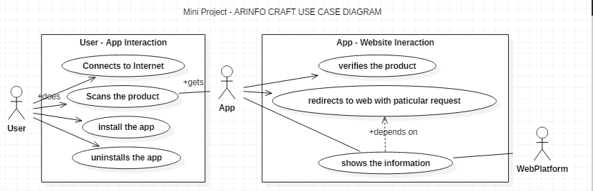

**6.2.2 SEQUENCE DIAGRAM:**

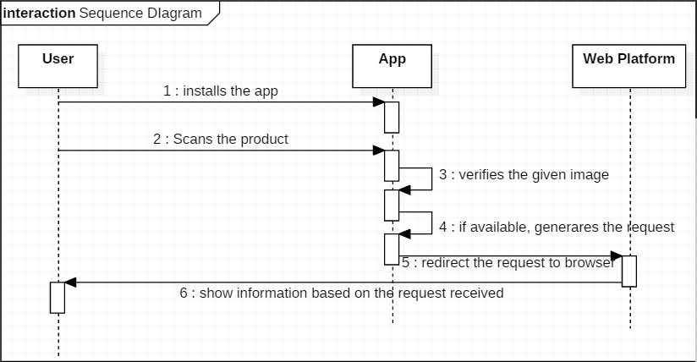

**6.2.3 CLASS DIAGRAM:**

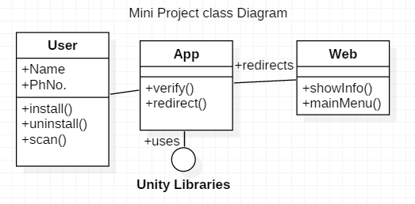

**6.4 HARDWARE ENVIRONMENT:**

**6.4.1 RF Technology:**

**Radio frequency** (**RF**) is a frequency or rate of oscillation within the range of about 3 Hz to 300 GHz. This range corresponds to frequency of alternating current electrical signals used to produce and detect radio waves. Since most of this range is beyond the vibration rate that most mechanical systems can respond to, RF usually refers to oscillations in electrical circuits or electromagnetic radiation.

**Properties of RF:**

Electrical currents that oscillate at RF have special properties not shared by direct current signals. One such property is the ease with which it can ionize air to create a conductive path through air. This property is exploited by 'high frequency' units used in electric arc welding. Another special property is an electromagnetic force that drives the RF current to the surface of conductors, known as the skin effect. Another property is the ability to appear to flow through paths that contain insulating material, like the dielectric insulator of a capacitor. The degree of effect of these properties depends on the frequency of the signals.

**DIFFERENT RANGES PRESENT IN RF AND APPLICATIONS IN THEIR RANGES**

|  |  |  |  |
| --- | --- | --- | --- |
| **Frequency** | **Frequency range** | **Distance** | **Uses** |
| **Extremely low frequency** | 3 to 30 Hz k | 10,000 km to 100,000 km | Directly audible when converted to sound, communication with submarines |
| **Super low frequency** | 30 to 300 Hz j | 1,000 km to 10,000 km | Directly audible when converted to sound, AC power grids (50 hertz and 60 hertz) |
| **Ultra low frequency** | c 300 to 3000 Hz i | 100 km to 1,000 km | Directly audible when converted to sound, communication with mines |

### WHY DO WE GO FOR RF COMMUNICATION?

### RF Advantages:

1. No line of sight is needed.
2. Not blocked by common materials: It can penetrate most solids and pass through walls.
3. Longer range.
4. It is not sensitive to the light;.
5. It is not much sensitive to the environmental changes and weather conditions.

**THE MAIN REQUIREMENTS FOR THE COMMUNICATION USING RF TECHNOLOGY**

* + **RF Transmitter**
  + **RF Receiver**

**RF TRANSMITTER:**

**Features**

* 433.92 MHz Frequency
* Low Cost
* 1.5-12V operation
* Small size

**RF RECEIVER:**

**Features**

* Operating voltage: 2.4V~12V.
* Low power and high noise immunity CMOS technology.
* Low standby current.

**6.4.2 GSM Technology:**

**Definition of GSM:**

GSM (Global System for Mobile communications) is an open, digital cellular technology used for transmitting mobile voice and data services.

GSM (Global System for Mobile communication) is a digital mobile telephone system that is widely used in Europe and other parts of the world. GSM uses a variation of Time Division Multiple Access (TDMA) and is the most widely used of the three digital wireless telephone technologies (TDMA, GSM, and CDMA). GSM digitizes and compresses data, then sends it down a channel with two other streams of user data, each in its own time slot. It operates at either the 900 MHz or 1,800 MHz frequency band. It supports voice calls and data transfer speeds of up to 9.6 kbit/s, together with the transmission of SMS (Short Message Service).

**Introduction to the GSM Standard**

The **GSM** (*Global System for Mobile communications*) network is at the start of the 21st century, the most commonly used mobile telephony standard in Europe. It is called as Second Generation (2G) standard because communications occur in an entirely digital mode, unlike the first generation of portable telephones.

When it was first standardized in 1982, it was called as **Group Special Mobile** and later, it became an international standard called **"Global System for Mobile communications"** in 1991.

**Architecture of the GSM Network**

In a GSM network, the user terminal is called a **mobile station**. A mobile station is made up of a **SIM** (*Subscriber Identity Module*) card allowing the user to be uniquely identified and a mobile terminal.

The terminals (devices) are identified by a unique 15-digit identification number called **IMEI** (*International Mobile Equipment Identity*). Each SIM card also has a unique (and secret) identification number called **IMSI** (*International Mobile Subscriber Identity*). This code can be protected using a 4-digit key called a *PIN code*.

The SIM card therefore allows each user to be identified independently of the terminal used during communication with a base station. Communications occur through a radio link (air interface) between a mobile station and a base station.

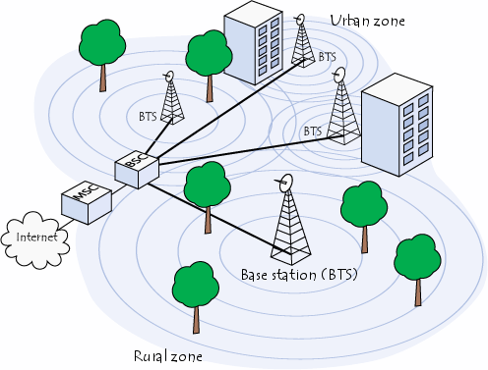

**Basic concepts of SMS technology**

## a. Validity Period of an SMS Message

An SMS message is stored temporarily in the SMS center if the recipient mobile phone is offline. It is possible to specify the period after which the SMS message will be deleted from the SMS center so that the SMS message will not be forwarded to the recipient mobile phone when it becomes online. This period is called the validity period.

A mobile phone should have a menu option that can be used to set the validity period. After setting it, the mobile phone will include the validity period in the outbound SMS messages automatically.

## b. Message Status Reports

Sometimes the user may want to know whether an SMS message has reached the recipient mobile phone successfully. To get this information, you need to set a flag in the SMS message to notify the SMS center that a status report is required about the delivery of this SMS message. The status report is sent to the user mobile in the form of an SMS message.

A mobile phone should have a menu option that can be used to set whether the status report feature is on or off. After setting it, the mobile phone will set the corresponding flag in the outbound SMS messages for you automatically. The status report feature is turned off by default on most mobile phones and GSM modems.

## 

## c. Message Submission Reports

After leaving the mobile phone, an SMS message goes to the SMS center. When it reaches the SMS center, the SMS center will send back a message submission report to the mobile phone to inform whether there are any errors or failures (e.g. incorrect SMS message format, busy SMS center, etc). If there is no error or failure, the SMS center sends back a positive submission report to the mobile phone. Otherwise it sends back a negative submission report to the mobile phone. The mobile phone may then notify the user that the message submission was failed and what caused the failure.

If the mobile phone does not receive the message submission report after a period of time, it concludes that the message submission report has been lost. The mobile phone may then send the SMS message again to the SMS center. A flag will be set in the new SMS message to inform the SMS center that this SMS message has been sent before. If the previous message submission was successful, the SMS center will ignore the new SMS message but send back a message submission report to the mobile phone. This mechanism prevents the sending of the same SMS message to the recipient multiple times.

Sometimes the message submission report mechanism is not used and the acknowledgment of message submission is done in a lower layer.

## d.Message Delivery Reports

After receiving an SMS message, the recipient mobile phone will send back a message delivery report to the SMS center to inform whether there are any errors or failures (example causes: unsupported SMS message format, not enough storage space, etc). This process is transparent to the mobile user. If there is no error or failure, the recipient mobile phone sends back a positive delivery report to the SMS center. Otherwise it sends back a negative delivery report to the SMS center.

If the sender requested a status report earlier, the SMS center sends a status report to the sender when it receives the message delivery report from the recipient. If the SMS center does not receive the message delivery report after a period of time, it concludes that the message delivery report has been lost. The SMS center then ends the SMS message to the recipient for the second time.

**Applications**

* GPRS Connectivity for serial/legacy devices such as Energy Meters, SCADA Systems, PLC, Machine Automation devices, RFID etc.
* Accurate timing for clocks and other systems from GPRS
* GSM/GPRS based reporting systems

**6.4.3 GPS Technology:**

The Global Positioning System (GPS) is a satellite based navigation system that sends and receives radio signals. A GPS receiver acquires these signals and provides the user with information. Using GPS technology, one can determine location, velocity and time, 24 hours a day, in any weather conditions anywhere in the world for free.

GPS was formally known as the NAVSTAR (Navigation Satellite Timing and Ranging). Global Positioning System was originally developed for military. Because of its popular navigation capabilities and because GPS technology can be accessed using small, inexpensive equipment, the government made the system available for civilian use. The USA owns GPS technology and the Department of Defense maintains it.

# How GPS works

* GPS is funded by and controlled by the U. S. Department of Defense (DOD). While there are many thousands of civil users of GPS worldwide, the system was designed for and is operated by the U. S. military.
* GPS provides specially coded satellite signals that can be processed in a GPS receiver, enabling the receiver to compute position, velocity and time.
* Four GPS satellite signals are used to compute positions in three dimensions and the time offset in the receiver clock.

**Determining Position:**

Upon taking in all available satellite signals, the receiver compares the time that the satellite sent the signal to the time it was received for each of the available signals. Trilateralization (similar to triangulation) then calculates the position by comparing the difference among the signals.

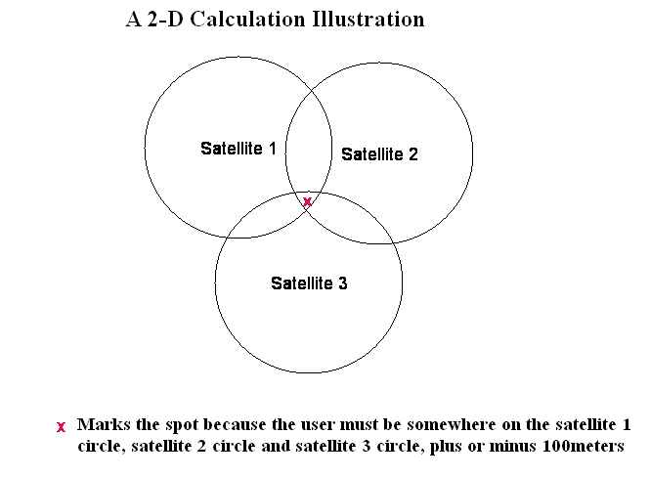

**Goal of the Global Positioning System**

***The Global Positioning System (GPS) includes 24 satellites, in circular orbits around Earth with orbital period of 12 hours, distributed in six orbital planes equally spaced in angle.***

**Accuracy of GPS:**

The accuracy of GPS depends on a number of factors, number of channels on the receiver, number of satellites in view, and signal interference caused by buildings, mountains and ionospheric disturbances. Accuracy should be within 15 meters (without SA) provided the receiver has a clear shot at a minimum of four satellites.

**GPS Applications**

One of the most significant and unique features of the Global Positioning Systems is the fact that the positioning signal is available to users in any position worldwide at any time. With a fully operational GPS system, it can be generated to a large community of likely to grow as there are multiple applications, ranging from surveying, mapping and navigation to GIS data capture. The GPS will soon be a part of the overall utility of technology.   
There are countless GPs applications, a few important ones are covered in the following section.

**Navigation**   
Navigation using GPS can save countless hours in the field. Any feature, even if it is under water, can be located up to one hundred meters simply by scaling coordinates from a map, entering waypoints and going directly to the site. Examples include road intersections, corner posts, plot canters, accident sites, geological formations etc. GPS navigation in helicopters, in vehicles, or in a ship can provide an easy means of navigation with substantial savings.

**Military**   
The GPS was primarily developed for real time military positioning. Military applications include airborne, marine, and land navigation.

**Geodesy**   
Geodetic mapping and other control surveys can be carried out effectively using high-grade GPs equipment. Especially when helicopters were used or when the line of sight is not possible, GPS can set new standards of accuracy and productivity.

**Factors that affect GPS**

There are a number of potential error sources that affect either the GPS signal directly or the user ability to produce optimal results:

* **Number of satellites-minimum number required:**

Atleast four common satellites must be tracked, the same four satellites at both the reference receiver and rover for either DGPS or RTK solutions. Also to achieve centimeter -level accuracy, it is necessary to have a fifth satellite for on-the fly RTK initialization. This extra satellite adds a check on the internal calculation. Any additional satellites beyond five provide even more checks, which is always useful.

* **Multipath-reflection of GPS signals near the antenna:**

Multipath is simply reflection of signals similar to the phenomenon of ghosting on our television screen. GPS signals may be reflected by surfaces near the antennae, causing error in the travel time and therefore error in the GPS positions.

* **Ionosphere - change in the travel time of the signal:**

Before GPS signals reach the antenna on the earth, they pass through a zone of charged particles called the ionosphere, which changes the speed of the signal. If the reference fixed by the user and rover receivers is relatively close together, the effect of ionosphere tends to be minimal. And if a lower range of GPS precisions is used, the ionosphere is not a major consideration. However if the rover is working too far from the reference station, problems may arise, particularly with initializing the RTK fixed solution.

* **Signal Strength - Quality of Signal** :

The strength of the satellite signal depends on obstructions and the elevation of the satellites above the horizon. To the extent it is possible, obstructions between the setup GPS antennae and the sky should be avoided. It is also suggested to watch out for satellites which are close to the horizon, because the signals are weaker.

A standard GPS receiver will not only place the user on a map at any particular location, but will also trace the path across a map as the user moves. If a receiver is left on, it can stay in constant communication with GPS satellites to see how the user location is changing. With this information and its built-in clock, the receiver can give several pieces of valuable information:

* How far the person have travelled (odometer)
* How long he has been traveling
* The current speed (speedometer)
* The average speed
* The estimated time of arrival at the destination if he maintains the current speed.

**Future of GPS Technology**

Barring significant new complications due to S/A (Selective Availability) from DOD, the GPS industry is likely to continue to develop in the civilian community. There are currently more than 50 manufacturers of GPs receivers, with the trend continuing to be towards smaller, less expensive, and more easily operated devices. While highly accurate, portable (hand-held) receivers are already available, current speculation envisions inexpensive and equally accurate 'wristwatch locators' and navigational guidance systems for automobiles. However, there is one future trend that will be very relevant to the GIS user community, namely, community base stations and regional receive networks, as GPS management and technological innovations that will make GPS surveying easier and more accurate.

### 7. SYSTEM TESTING

**7.1 INTRODUCTION:**

The purpose of testing is to discover errors. Testing is the process of trying to discover every conceivable fault or weakness in a work product. It provides a way to check the functionality of components, sub assemblies, assemblies and/or a finished product.

It is the process of exercising software with the intent of ensuring that the Software system meets its requirements and user expectations and does not fail in an unacceptable manner. There are various types of test. Each test type addresses a specific testing requirement.

Software system meets its requirements and user expectations and does not fail in an unacceptable manner. There are various types of test. Each test type addresses a specific testing requirement.

System testing is designated to uncover weakness that was not detected in the earlier tests. The total system is tested for recovery and fallback after various major failures to ensure that no data are lost. An acceptance test is done to   validity and reliability of the system. The philosophy behind the testing is to find error in project.

**7.2 TYPES OF TESTS:**

**Unit testing:**

Unit testing involves the design of test cases that validate that the internal program logic is functioning properly, and that program inputs produce valid outputs. All decision branches and internal code flow should be validated. It is the testing of individual software units of the application .it is done after the completion of an individual unit before integration. This is a structural testing, that relies on knowledge of its construction and is invasive. Unit tests perform basic tests at component level and test a specific business process, application, and/or system configuration. Unit tests ensure that each unique path of a business process performs accurately to the documented specifications and contains clearly defined inputs and expected results.

**Integration testing:**

Integration tests are designed to test integrated software components to determine if they actually run as one program. Testing is event driven and is more concerned with the basic outcome of screens or fields. Integration tests demonstrate that although the components were individually satisfaction, as shown by successfully unit testing, the combination of components is correct and consistent. Integration testing is specifically aimed at exposing the problems that arise from the combination of components.

In this many tested modules are combined into subsystems, which were then tested. Test case data is prepared to check the control flow of all the modules and to exhaust all possible inputs to the program.Situations like treating the modules when there is no data entered in the text box is also tested.

This testing strategy dictates the order in which modules must be available, and exerts strong influence on the order in which the modules must be written, debugged and unit tested. In integration testing, all the modules / units on which unit testing is performed are integrated together and tested.

**Functional testing:**

Functional tests provide systematic demonstrations that functions tested are available as specified by the business and technical requirements, system documentation, and user man

Functional testing is centered on the following items:

Valid Input : identified classes of valid input must be accepted.

Invalid Input : identified classes of invalid input must be rejected.

Functions : identified functions must be exercised.

Output : identified classes of application outputs must be exercised.

Systems/Procedures: interfacing systems or procedures must be invoked.

Organization and preparation of functional tests is focused on requirements, key functions, or special test cases. In addition, systematic coverage pertaining to identify Business process flows; data fields, predefined processes, and successive processes must be considered for testing. Before functional testing is complete, additional tests are identified and the effective value of current tests is determined.

Software Testing:

As the coding is completed according to the requirement we have to test the quality of the software. Software testing is a critical element of software quality assurance and represents the ultimate review of specification, design and coding. Although testing is to uncover the errors in the software but it also demonstrates that software functions appear to be working as per the specification, those performance requirements appear top have been met. In addition, data collected as testing is conducted provide a good indication of software reliability and some indications of software quality as a whole.

To assure the software quality we conduct both White Box Testing and Black Box Testing.

**White Box Testing:**

White Box Testing is a test case design method that uses the control structure of the procedural designs to derive test cases. As we are using a non-procedural language, there is very small scope for the White Box Testing. Whenever it is necessary, there the control structures are tested and successfully passed all the control structures with a very minimum error.

**Black Box Testing:**

Black Box Testing focuses on the functional requirement of the software.It enables to derive sets of input conditions that will fully exercise all functional requirements for a program.

The Black Box Testing finds almost all errors.If finds some interface errors and errors in accessing the database and some performance errors. In Black Box Testing we use mainly two techniques Equivalence Partitioning the Boundary Volume Analysis Technique.

Equivalence Partitioning:

In this method we divide input domain of a program into classes of data from which test cases are derived. An Equivalence class represents a set of valid or invalid or a set of related values or a Boolean condition. The equivalence for these is:

Input condition requires specific value-specific or non-specific two classes.

* Input condition requires a range-in the range or out of range two classes.
* Input condition specifies a member of a set-belongs to a set or not belongs to the set two classes.
* Input condition is Boolean-valid or invalid Boolean condition two classes.

By these types of equivalent classes, we can test for many cases.

Boundary Values Analysis:

Number of errors usually occurs at the boundaries of the input domain generally. In this technique a selection of test cases is exercised using boundary values i.e., around boundaries.

By the above two techniques, we eliminated almost all errors from the software and checked for numerous test values for each and every input value. The results were satisfactory.

## Code Testing:

Specification testing is done to check if the program does with it should do and how it should behave under various condition or combinations and submitted for processing in the system and it s checked if any overlaps occur during the processing.

This strategy examines the logic of the program. Here only syntax of the code is tested. In code testing syntax errors are corrected, to ensure that the code is perfect.

## Unit Testing:

The first level of testing is called unit testing. Here different modules are tested against the specifications produced during the design of the modules. Unit testing is done to test the working of individual modules with test oracles.

Unit testing comprises a set of tests preformed by an individual programmer prior to integration of the units into a large system. A program unit is usually small enough that the programmer who developed it can test it in a great detail. Unit testing focuses first on the modules to locate errors. These errors are verified and corrected so that the unit perfectly fits to the project.

**Acceptance Testing:**

This testing is performed finally by user to demonstrate that the implemented system satisfies its requirements. The user gives various inputs to get required outputs.

**Specification Testing:**

Specification testing is done to check if the program does what it should do and how it should behave under various conditions or combination and submitted for processing in the system and it is checked if any overlaps occur during the processing.

**Performance Time Testing:**

Performance time testing is done to determine how long it takes to accept and respond i.e., the total time for processing when it has to handle quite a large number of records. It is essential to check the exception speed of the system, which runs well with only a handful of test transactions. Such systems might be slow when fully loaded. So testing is done by providing large number of data for processing. A system testing is designed to uncover weaknesses that were not detected in the earlier tests.

The total system is tested for recovery and fallback after various major failures to ensure that no data are lost during an emergency. An acceptance test is done to ensure the user about the validity and reliability of the system.

**7.3 Test objectives:**

* All hardware must be properly connected.
* The GSM and GPS modules must be working simultaneously.
* The message about location when connection is lost must not be delayed.

### 8.CODE

1. Obtaining keys for respective images to use in unity via Vuforia and Setting up the environment

Go to Vuforia developer website then login/signup

Then go to developer tab and select create new key

Then go to the package tab where select the new project, here we can find the option to upload the images.Using this we uploaded the images/logos of the product

After Uploading the images we can also view the interaction points

Then download the unity package which will help us to use those images as ImageTargets in the unity Engine

2. verifying the product:   
 For this we need an image target to do so:

1. Redirecting to the website:  
    For this we need an C# script to do so:

using System. Collections;  
using System.Collections.Generic;  
using UnityEngine;  
using Vuforia;  
  
public class gdBlue : MonoBehaviour,IVirtualButtonEventHandler {  
    public GameObject g;  
    *// Use this for initialization*  
    void Start () {  
        g = GameObject.Find ("actionButton1");  
        g.GetComponent<VirtualButtonAbstractBehaviour> ().RegisterEventHandler (this);      
    }  
    public void OnButtonPressed(VirtualButtonAbstractBehaviour vb)  
    {  
    }  
    public void OnButtonReleased(VirtualButtonAbstractBehaviour vb)  
    {  
        Application.OpenURL ("http://192.168.137.1:8080/tables/gdBlue.html");  
    }  
}